Bram Stoker’s Dracula, by F.F. Coppola. Second extract.
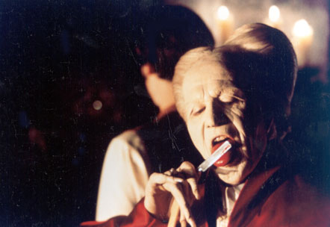

Castle Dracula, Harker's Bedchamber

JONATHAN HARKER'S JOURNAL, 3Oth May, Castle Dracula: I think
strange things which I dare not confess to my own soul. The
Count, the way he looked at Mina's picture fills me with dread
as if I have a part to play in a story that is not known to me.

Harker shaves while looking into a small mirror
Harker cuts himself with the razor
Enter Dracula

HARKER: I didn't hear you come in.

DRACULA: Take care how you cut yourself. It is more dangerous
than you think.

Dracula breaks the mirror

DRACULA: A foul bauble of man's vanity. Perhaps you should
grow a beard.

Dracula takes the razor, turns and licks off the blood

DRACULA: The letters I requested...have you finished them?

Harker hands Dracula three letters

DRACULA: Good.

DRACULA: Should you leave these rooms, you will not by any
chance go to sleep in any other part of the castle. It is old
and has many bad memories. Be warned.

HARKER: I'm sure I understand.

Dracula sees a crucifix around Harker's neck
He snarls and pushes Harker away

DRACULA: Do not put your faith in such trinkets of deceit! We
are in Transylvania, and Transylvania is not England. Our ways
are not your ways. And, to you, there shall be many strange
things.

HARKER: I've seen many strange things already...bloody wolves
chasing me through some blue inferno!

Harker peers out the window to see wolves howling in the courtyard

DRACULA: Listen to them, the children of the night. What sweet
music they make.

HARKER: Music? Those animals?

Exit Dracula
Exit Dracula's shadow
Harker peers outside the window
to see Dracula crawling, like a reptile, up the castle wall

JONATHAN HARKER'S JOURNAL: I did as Dracula instructed. I
wrote three letters--to the firm, to my family, and to my
beloved Mina. I said nothing of my fears as he will read them,
no doubt. I know now that I am a prisoner.

LATER THAT NIGHT
Harker wanders the castle
He finds an unused bedchamber

VAMPIRESS: Jonathan! Jonathan, come to me! Come! Lay down,
lay back into my arms. Lay back, Jonathan.

Three vampiresses seduce Harker
They bite and suck him
Enter Dracula

DRACULA (translation): How dare you touch him! He belongs to
me!

VAMPIRESS (translation): You yourself never loved!

DRACULA (translation): Yes, I too can love. And I shall love
again.

VAMPIRESS (translation): Are we to have nothing tonight?

Dracula gives the vampiresses a human baby

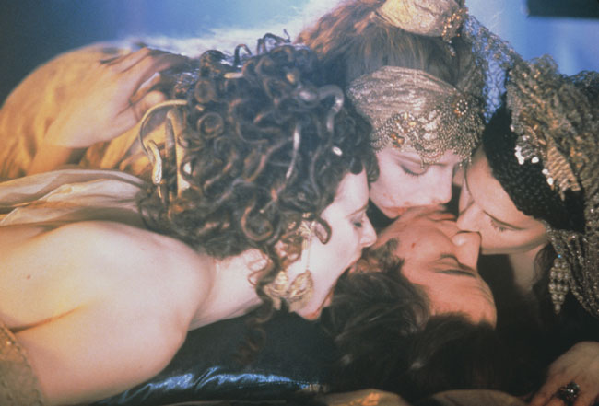

This script was transcribed by BJ Kuehl.

